HW #6 Theory Q’s

1. public class Walrus extends Animal {

}

1. (a) Upcasting
2. Yes, because upcasting is always possible. It is done implicitly and automatically. You can call it as a declared type.

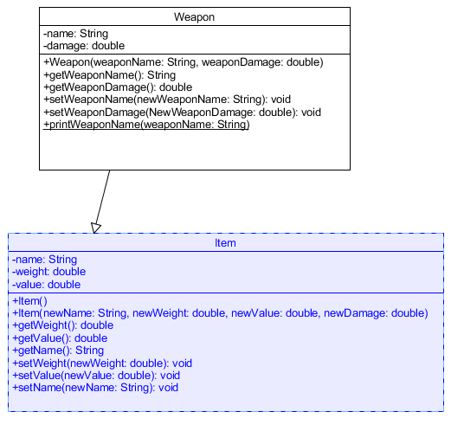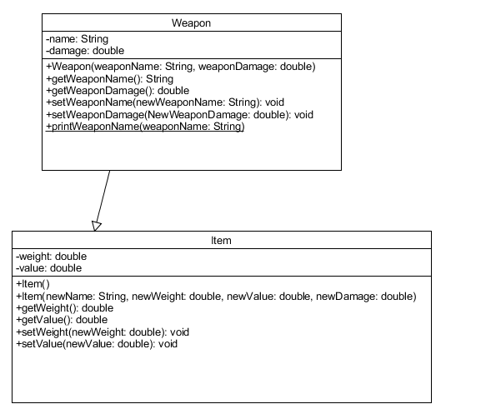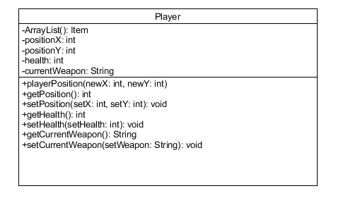

1. True
2. True
3. True
4. The “Object” class.
5. instanceof
6. B.
7. C.